POSTER’S GUIDELINES FOR POSTER SUBMISSION
Please follow the below guidelines exactly; the Conference Organisers will reserve the right to reject abstracts that do not comply.

General rules for formatting:
Poster size and orientation
Poster size: 9:16 (1920 px height x 1080 px width)¹
Orientation: Portrait
File Name: Name_Surname.PDF (Presenting Author)

Order of sections:
1.- Congress logo (Top right)
2.-Title (text center-aligned)
3.-Authors (text center-aligned)
4.-Affiliation (text center-aligned)
5.-Presenting Author Email (text center-aligned)
6.-Poster content (Freestyle but text alignment “justified” FOLLOWING the IMRAD structure as mandatory)
7.-References² and Acknowledgments
8.-Logos (text center-aligned)
9.-Freestyle for Background color and Fonts (Choose appropriate and easy to read fonts)

Language
All Posters text must be in English

¹HOW TO CREATE A 9:16 POSTER
Adobe InDesign or Alike:
Create new file -> 1920 px height by 1080 px width -> 300 DPI Resolution -> Follow the recommended Order of sections -> Save As PDF Following the File name requested

PowerPoint:
Create new file -> File -> Page settings -> Choose screen size 16:9 -> Choose vertical Orientation Follow the recommended Order of sections -> File -> Save As PDF Following the File name requested
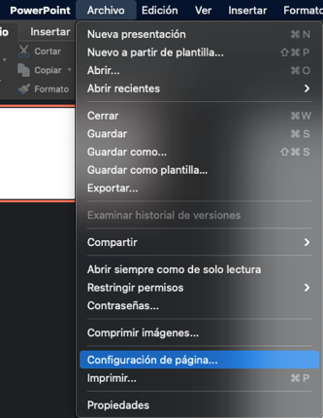
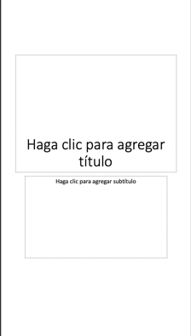
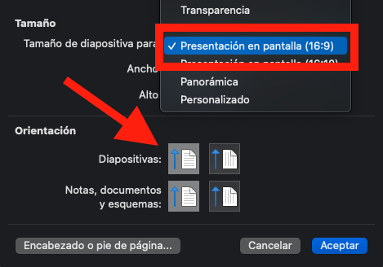
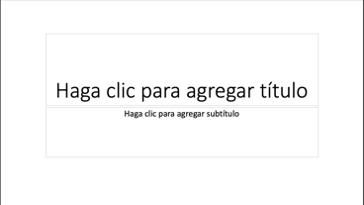

²References: Citations should be in-line, as a number enclosed in square brackets [1]. The corresponding reference list (in numerical order Please use this order: Authors, Year, Journal, Issue, Pages.
FAQs
Which size in cm is necessary for my poster?
Digital formatting does not need specific sizes in cm, rather "px" is used because the ratio on screens changes, therefore, following the "Poster size instructions" would be the only necessary attribute.

How do I ensure that my images will have good quality?
In order to not lose quality .PNG files or alike are suggested, simple "copy-paste" might provide lower quality and much heavier image.

Where can I get the Congress logo?
We are attaching in this email the proper files.

Can I display tables as Images?
Is not recommended, Ideal formatting would be working table on the Poster document or copy them as .PNG or alike

This is the first time I'm sending a digital poster, how can I know is in the correct proportions?
Open your .PDF on a big TV or projector and verify if you like the distribution, Also, you can open the file on your phone and zoom in as much as possible, and check if your images, tables, or fonts are clear.

